Q-1. Write an SQL query to print details of workers excluding first names, “Vipul” and “Satish” from Worker table.
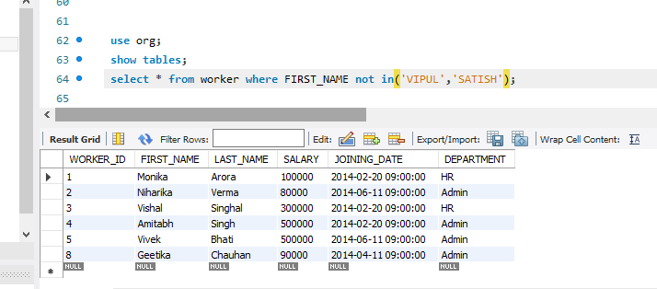

Q-2. Write an SQL query to print details of the Workers whose FIRST_NAME ends with ‘h’ and contains six alphabets.
